Wingard Quality Supply, LLC
44901 Industrial Drive
Fremont, CA 94538
(510) 743-1090
(510) 743-1089 fax

To: NUMMI Tire and Wheel Suppliers & Logistics Companies

Subject: Forecast, Orders, and Invoicing Information Flow After Transfer of Procurement
responsibility From NUMMI to Wingard Quality Supply, LLC (WQS)

From: Paul Hodnett

Dear NUMMI Suppliers and Logistics Professionals,

As you know, TMMNA and NUMMI have requested that WQS accept procurement responsibility for all of their wheels and tires including managing all of the relative logistics involved with these parts. WQS has already successfully assumed all wheel assembly mounting operations for NUMMI and is looking forward to this new responsibility. For all of us to be successful, we’ll need to work together closely to ensure our customers get the best possible parts and deliveries.

To ensure we meet our customer’s needs, we have built an automated information system that will require active participation from all suppliers and logistics companies. We encourage constructive input from all companies. It is our goal to make this transition as smooth as possible. If there are technical problems, we want to work closely together to solve such issues. Please contact Dave Verespey, Automated Systems Engineer, as soon as possible if you feel your current system cannot adapt.
David Verespey
Fail Proof Manufacturing Systems
dverespey@failproofmfg.com
(510) 770-4539

SYSTEM OVERVIEW
An “Information Flow Diagram” is attached for your reference. Our ordering and inventory system will be updated with information through dedicated FTP sites. Each supplier will be assigned an address and a secure log-on to access their forecasts and orders. Suppliers can also, if they so choose, send their invoices electronically. When forecasts or orders are updated for individual suppliers, e-mails will automatically be generated and sent to designated individuals to inform them that forecasts and/or orders are available for downloading. Forecasts and orders will be in the form of an Excel spreadsheet. We’ll e-mail your company’s IT contact within the next few days with FTP addresses, log-on and password information.

A daily “Download” report will automatically be generated each day to identify those suppliers that failed to download their new orders. From this report, we’ll personally contact suppliers and remind them that they have new orders to download.

Part number forecasts, sorted by supplier, will be generated once each week and will be based solely on the production forecast received from NUMMI. Parts Orders will be rounded to lot quantities and will be calculated based on:

- Forecasted usage
- On-hand inventory
- Pipe-line inventory
- Lead-time
- Desired safety stock

All of us here at WQS are looking forward to our new relationships. I’m confident that our teamwork will make this transition a smooth one. Please don’t hesitate to call me for any reason. (510) 743-1090 x 13

Sincerely,

Paul Hodnett
Plant Manager

Attachment
- Information Flow Diagram

WINGARD QUALITY SUPPLY, LLC
SELF-PROCUREMENT INFORMATION FLOW

DOWNLOAD REPORT
Download reports will be generated each day and will include a list of all suppliers that failed to download their orders.

NUMMI

Supplier A

Supplier B

Supplier C

Supplier D

Supplier E


Logistics Company

Forecast

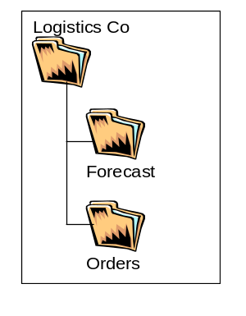





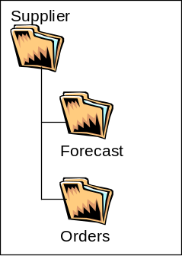
Wingard Quality Supply

WQS INVENTORY & ORDERING SYSTEM

E-mails are sent to designated company representatives when forecasts and orders have been updated on the FTP site.
Forecast
Container Updates

Invoices

WQS FTP SITE

